- AP Chinese Language and Culture Exam Day

Exam Format
The AP Chinese Language and Culture Exam has consistent question types, weighting, and scoring guidelines every year, so you and your students know what to expect on exam day.
Section 1A: Multiple Choice Listening
25–35 Questions | 20 Minutes | 25% of Exam Score
- This section consists of a variety of audio materials. It is divided into two subsections:
  - Identify the appropriate continuation of a conversation
  - Answer questions about different types of listening stimuli (e.g., transportation announcements, voice messages, school conversations, radio reports, instructions, and uncontextualized dialogues)
- Students will be asked to:
  - Identify the main ideas and supporting details in the audio material
  - Determine the meaning of a variety of vocabulary and deduce the meaning of unfamiliar words
  - Decide the meaning of a text based on cultural and/or interdisciplinary information
  - Infer implied meaning through context
Section 1B: Multiple Choice Reading
30–40 Questions | 60 Minutes | 25% of Exam Score
- This section consists of a variety of print materials (e.g., notes, emails about sequence of events, pen pal letters, poster announcements, and short stories).
- Students will be asked to:
  - Identify the main ideas and supporting details in the written material
  - Determine the meaning of a variety of vocabulary and deduce the meaning of unfamiliar words
  - Decide the meaning of a text based on cultural and/or interdisciplinary information
  - Infer implied meaning through context
Section 2A: Free Response Written
2 Tasks | 30 Minutes | 25% of Exam Score
- Presentational Writing: Narrate a story suggested by a series of pictures (15 minutes)
- Interpersonal Writing: Read and answer an email message (15 minutes)
Section 2B: Free Response Spoken
2 Tasks | 10 Minutes | 25% of Exam Score
- Interpersonal Speaking: Respond to a series of thematically linked questions as part of a simulated conversation (4 minutes)
- Presentational Speaking: Deliver a presentation on a given aspect of Chinese culture (choose and describe one Chinese cultural practice or product, and explain its significance) (1 prompt; 7 minutes, preparation time: 4 minutes; response time: 2 minutes)

Exam Questions and Scoring Information

2020 Free-Response Questions
2020 free-response questions are now in the AP Classroom question bank for teachers to assign to students as homework or in class, and do not require secure assessment. These questions have been updated, where possible, to best match the format of free-response questions in the course and exam description and on traditional AP Exams.
Sign in to AP Classroom to access resources including personal progress checks and a question bank with topic questions and practice exams aligned to the current course and exam.
To preserve the large number of new FRQs for teacher use, only teachers have access to the 2020 FRQs. If you are a higher education faculty member interested in seeing questions, please fill out this request form.

2019 Free-Response Questions
For free-response questions (FRQs) from the 2019 exam, along with scoring information, check out the table below.
Be sure to review the Chief Reader Report. In this invaluable resource, the chief reader of the AP Exam compiles feedback from members of the AP Reading leadership to explain how students performed on the FRQs, summarize typical student errors, and address specific concepts and content with which students have struggled the most that year.

5 Steps to a 5: AP Chinese Language and Culture Paperback – Audiobook, Aug. 1 2018
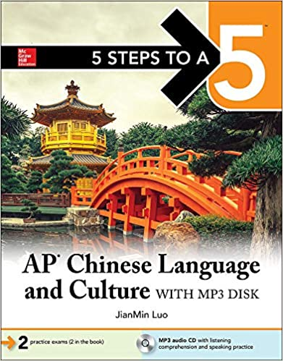

Barron's AP Chinese Language and Culture with MP3 CD, 2nd Edition (Barron's Educational Series) 2nd Edition
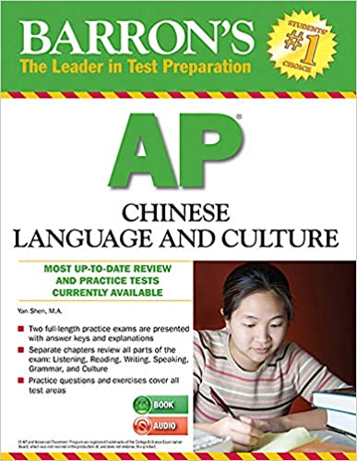

AP Chinese Language and Culture Simulated Tests (Free Audio Downloads) by Sunny X. Yu Bih-Hsya Hsieh (2010-05-04) Paperback – January 1, 2010
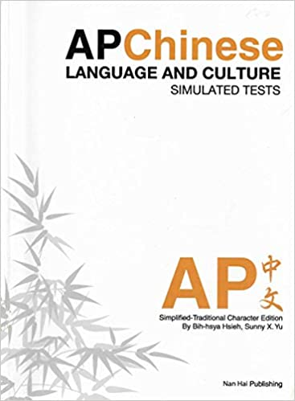

Strive For a 5: AP Chinese Practice Tests (Cheng & Tsui Ap Preparation Series) (English and Chinese Edition) (Chinese) 1st Edition
